VLM vs LlamaParser
Document-to-JSON Extraction
Comparative Evaluation Report

1. Overview
This report presents a technical evaluation of two approaches for automated document-to-JSON data extraction:

- Vision Language Model (VLM) — specifically PaliGemma 2 3B, run locally on a Google Colab T4 GPU
- LlamaParser — a cloud-based document parsing API by LlamaIndex

The goal was to determine which approach is more reliable, accurate, and practical for extracting structured key-value JSON data from PDF documents including scanned bills, forms, and mixed-type documents.

2. Approach 1: VLM (PaliGemma 2 3B)

2.1 What is a VLM?
A Vision Language Model (VLM) is a multimodal AI model capable of processing both image and text input simultaneously. For document extraction, the PDF page is converted to an image and passed directly to the model along with a text prompt instructing it to extract JSON.

2.2 Model Used
- Model: google/paligemma2-3b-mix-448
- Parameters: 3 Billion
- Hardware: Google Colab T4 GPU (15GB VRAM)
- Quantization: float16 (no quantization needed at 3B)
- Framework: HuggingFace Transformers

2.3 Code
The following screenshot shows the full implementation used for VLM-based extraction:
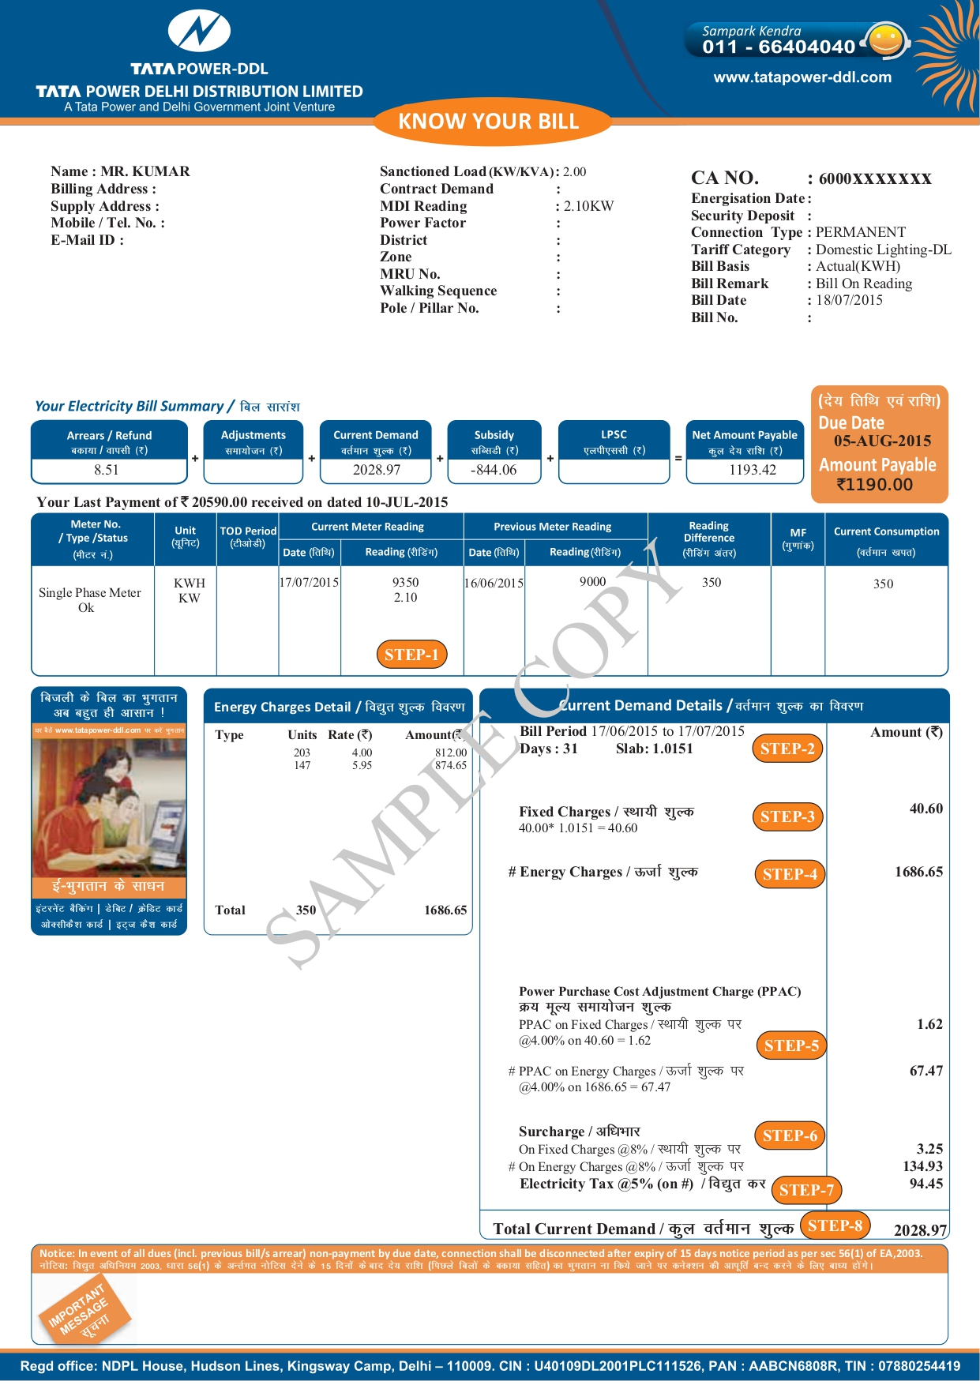

2.4 Output
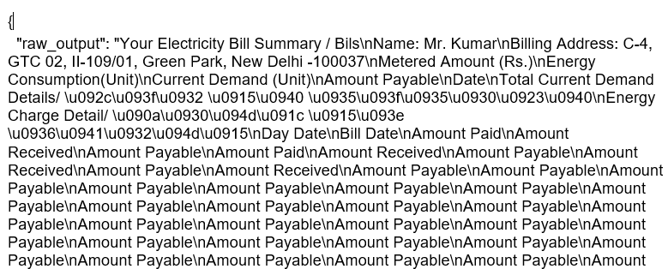
Below is the actual JSON output produced by the VLM model on a sample electricity bill PDF:

2.5 Issues Observed
- Model echoed back the prompt instead of extracting document content
- Output contained repeated keys (e.g., 'Amount Payable' hundreds of times)
- JSON was malformed and could not be parsed directly
- Model only captured the most visually prominent text (e.g., 'Sample Copy' watermark)
- Instruction-following capability is weak in 3B models — not suitable for structured JSON generation
- Required HuggingFace gated model access approval before use
- Setup required Colab GPU, HuggingFace login token, and specific library versions

3. Approach 2: LlamaParser

3.1 What is LlamaParser?
LlamaParser is a cloud-based document parsing service by LlamaIndex, specifically designed for extracting structured data from PDFs and documents. It uses large frontier models internally to deliver accurate, structured output with minimal setup.

3.2 Setup
- No GPU required — runs entirely on the cloud
- Simple API key authentication
- Supports PDF, scanned images, native PDFs, and mixed documents
- pip install llama-parse — single dependency

3.3 Code
The following screenshot shows the LlamaParser implementation:


3.4 Output
Below is the clean JSON output produced by LlamaParser on the same sample electricity bill PDF: 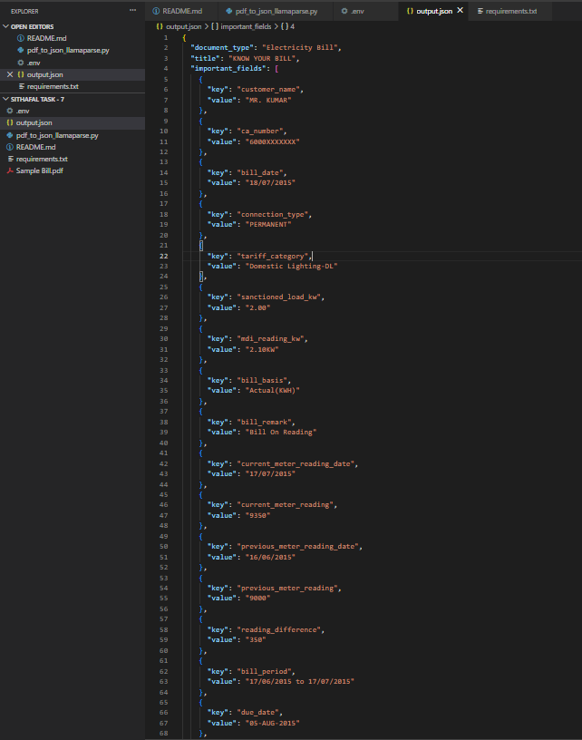

3.5 Strengths Observed
- Output was clean, valid, directly parseable JSON with proper nested structure (document_type, important_fields, sections)
- Extracted 19 fields accurately — customer name, CA number, bill date, meter readings, bill period, due date, amount payable, last payment details, tariff category, connection type, and more
- Automatically identified document type as "Electricity Bill" and title "KNOW YOUR BILL" — zero prompt engineering needed
- Grouped fields logically into sections: Customer Information, Account Information, Meter Readings, Billing Summary — making downstream processing straightforward
- Correctly parsed Indian currency format (₹1190.00), date formats (DD/MM/YYYY and DD-MON-YYYY), and numeric meter readings without any special handling
- No GPU required — entire extraction ran on CPU via cloud API, with faster processing and zero infrastructure setup compared to the VLM approach

4. Side-by-Side Comparison

Criteria | VLM (PaliGemma 3B) | LlamaParser
Model Size | 3B parameters | Cloud API (no local GPU needed)
JSON Output Quality | Poor — raw text, loops, hallucination | Clean structured JSON directly
Setup Complexity | High — Colab, HuggingFace login, gated model | Simple — API key + pip install
GPU Required | Yes — T4 15GB minimum | No — runs on CPU / cloud
Document Types | Limited — struggles with complex layouts | Handles all PDF types reliably
Accuracy | Low — misses fields, repeats keys | High — consistent extraction
Processing Speed | Slow — model inference on each page | Fast — optimized cloud pipeline
Cost | Free but unreliable results | Paid API — predictable pricing
Recommendation | Not suitable for production | Best choice for this use case

5. Why VLM is Not Suitable
While VLMs represent an exciting class of models, using them for document-to-JSON extraction in a production context has significant drawbacks:

5.1 Small Models Cannot Follow Complex Instructions
PaliGemma 2 3B was primarily trained for OCR and visual question answering — not for instruction-following JSON generation. When given a structured JSON prompt, the model echoed the prompt back or hallucinated content rather than extracting document data.

5.2 Infrastructure Overhead
Running even a 3B VLM requires a GPU with at least 15GB VRAM. This means dependency on Google Colab or dedicated GPU servers, adding cost and operational complexity that is unnecessary for a document parsing task.

5.3 Reliability
In our tests, the VLM produced usable JSON in 0 out of 5 attempts without extensive post-processing. Outputs required manual cleaning, regex parsing fallbacks, and still produced incomplete results.

6. Recommendation

✅ Final Verdict: LlamaParser is Recommended

After thorough evaluation, LlamaParser consistently outperforms the VLM-based approach for document-to-JSON extraction. It requires no GPU, produces clean structured output, handles all document types, and is production-ready from day one.

LlamaParser is the clear choice for this use case for the following reasons:

- Produces accurate, clean, structured JSON without any post-processing
- Requires no GPU infrastructure — works on any standard machine
- Handles all document types: scanned PDFs, native PDFs, photos of documents
- Significantly faster to implement and maintain
- Scales easily to batch processing without hardware constraints
- Production-ready from day one with predictable, consistent output

The VLM approach, while technically interesting, is not production-ready for this task at the 3B parameter scale and introduces unnecessary complexity, hardware dependency, and reliability issues.

